Table 1. Capture of triatomines and other insects in houses by way of entomological monitoring with communitary participation implemented in localized CPs in the region of the Mesothermic valleys in three departments in Bolivia
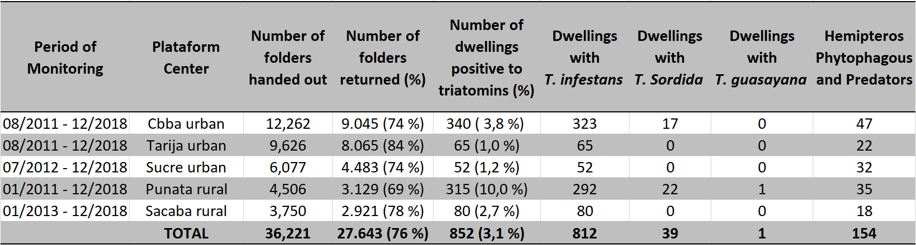

Table 2. Description of areas where houses were detected as being positive with triatomines (T. Infestans, T. Sordida, T. Guasayana) and place of capture within the house by members of families in three endemic departments of Bolivia. Determining of index Trypano/Triatominic of infected triatomines
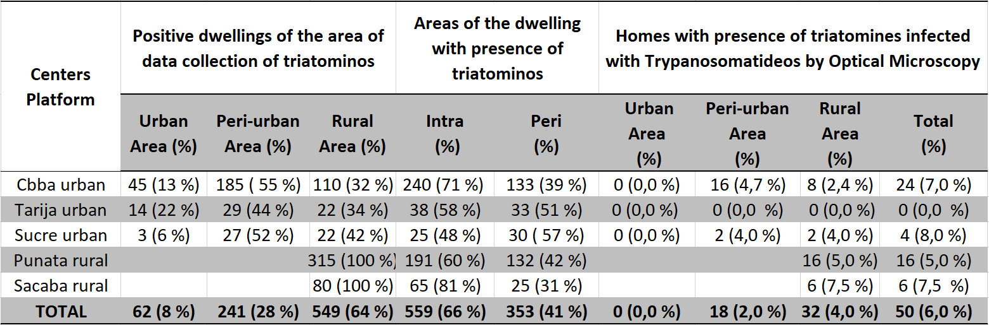

Graph 1. Average of positive houses with presence of triatomines relevant to yearly seasons (2011 – 2018) in the mesothermic valleys of the endemic areas of Bolivia (A urban and B rural areas).
A
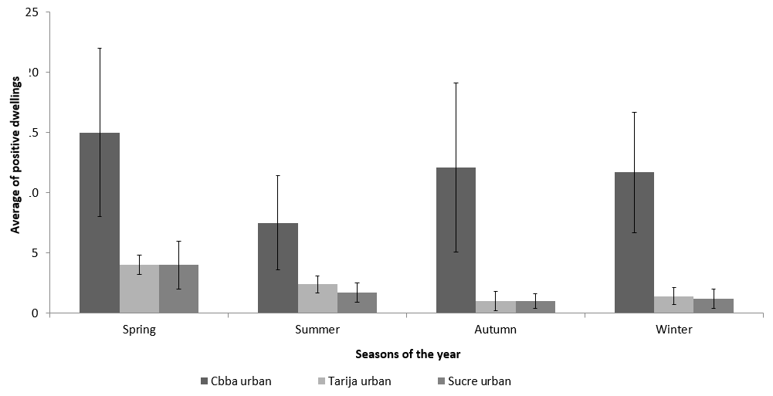
B
